Laravel Advanced Authentication

Run **$php artisan make:auth**.

Run **$php artisan make:migration create-admins-table - -create=admins.**

Run **$php artisan migrate.**

Inside migrations copy the users table entries into the new admins table.

Duplicate the User model and rename it Admin.php. (Rename the class also).

Inside config > auth.php enter:

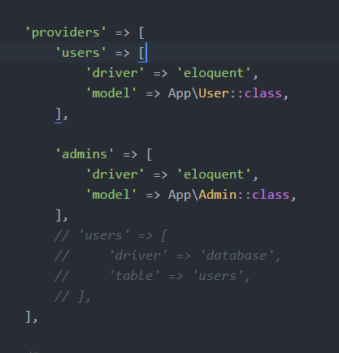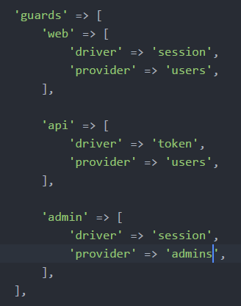

For api:

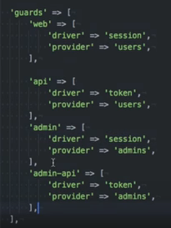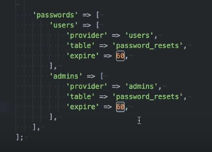

Inside admin.php enter:

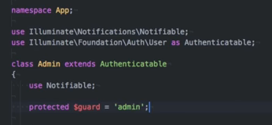

Inside routes > web.php enter:

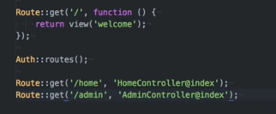

Duplicate the HomeController and rename it AdminController along with the class also.

admin will be the view name:

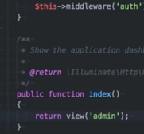

Duplicate the [home.blade.php](http://home.blade.php) file and rename it admin.blade.php.

Update the new admin.blade.php:

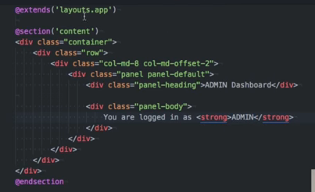

Update the [home.blade.php](http://home.blade.php) also with ‘User Dashboard’ and ‘You are logged in as <strong>USER</strong>.

Inside AdminController.php enter:

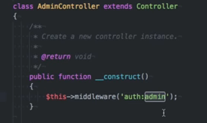

Now, the user logs in and is sent to the users dashboard. If they type into the address bar ‘admin’, they will just be sent to the users dashboard.